## Total dose of pipecuronium during hospital stay (for patients who are ventilated)

### IT-ITT and IT-PP populations

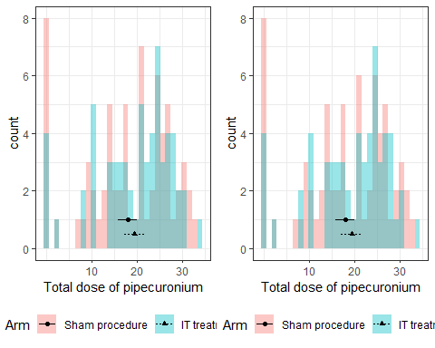

### IM-ITT and IM-PP populations

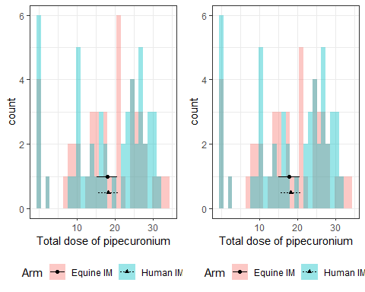

### IM-ALL population

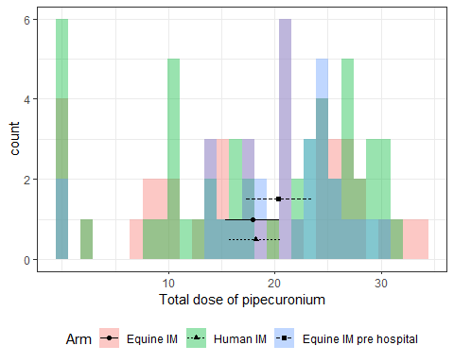

## Total duration of pipecuronium

### IT-ITT and IT-PP populations

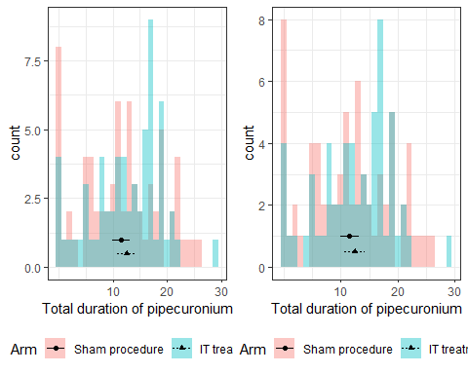

### IM-ITT and IM-PP populations

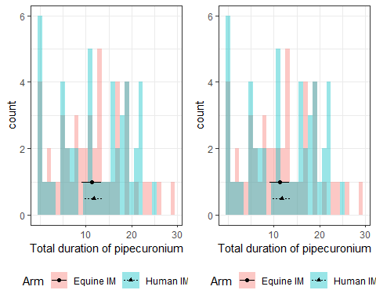

### IM-ALL population

